Sale Module

Your tasks:

1. Create a class diagram to support the above case study and Systems Use Case Specifications

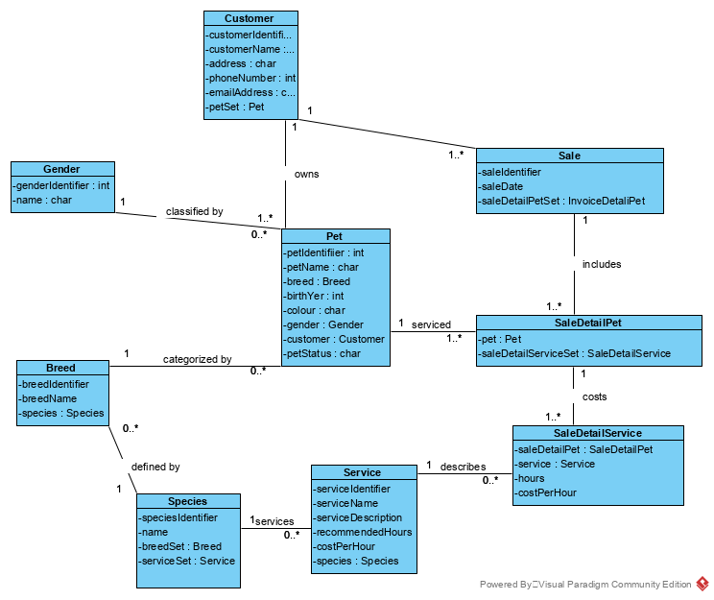

1. Create an object level sequence diagram, detailing the Create Customer systems use case specification

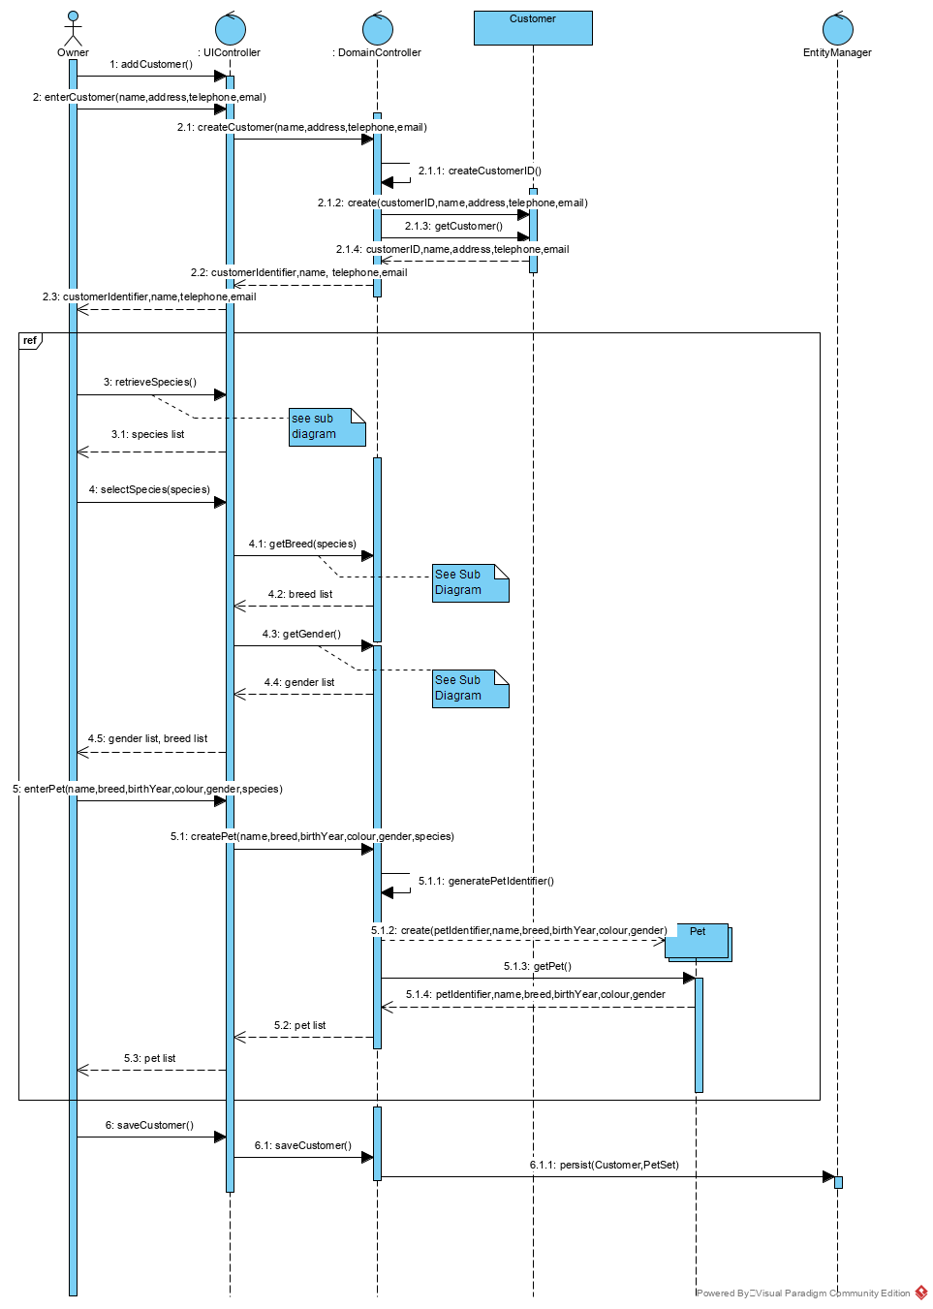

Retrieve Species

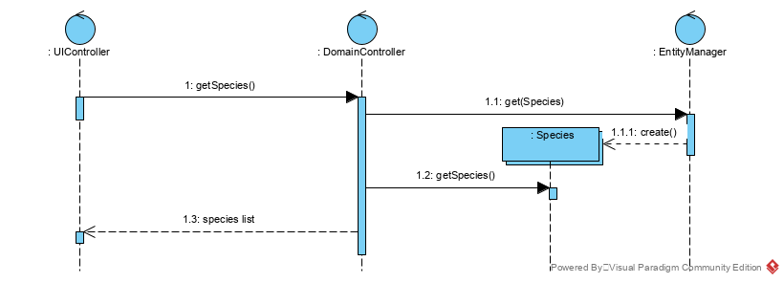

Get Breed

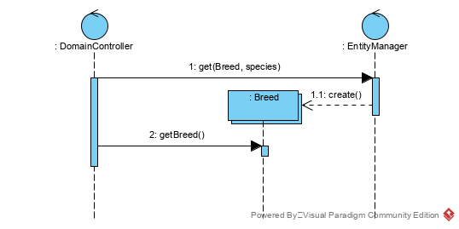

Get Gender

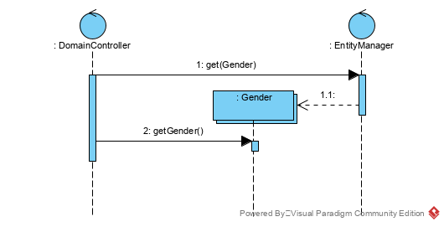

1. Create an object level sequence diagram, detailing the Create Sales use case specification

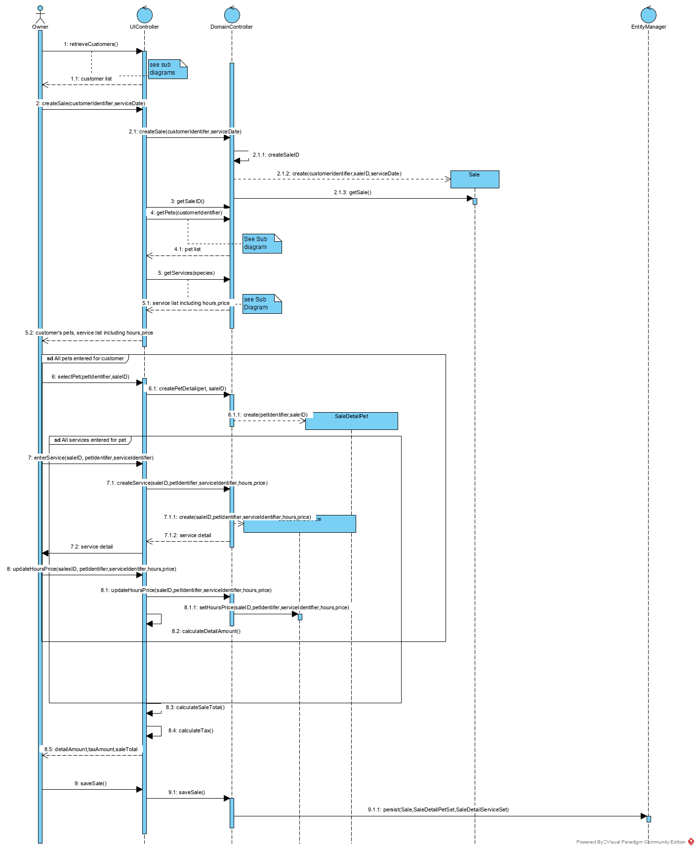

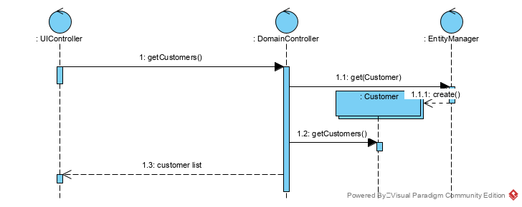

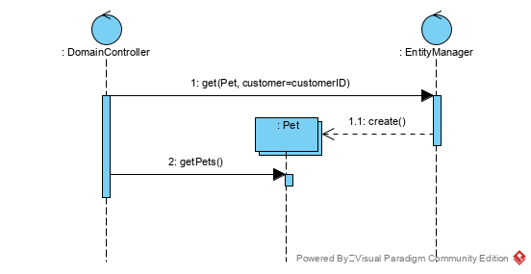

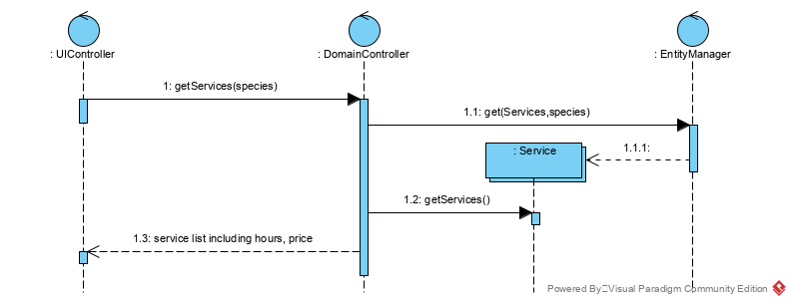

1. Create an object level sequence diagram, detailing the Query Sales (by customers) system use case specification.

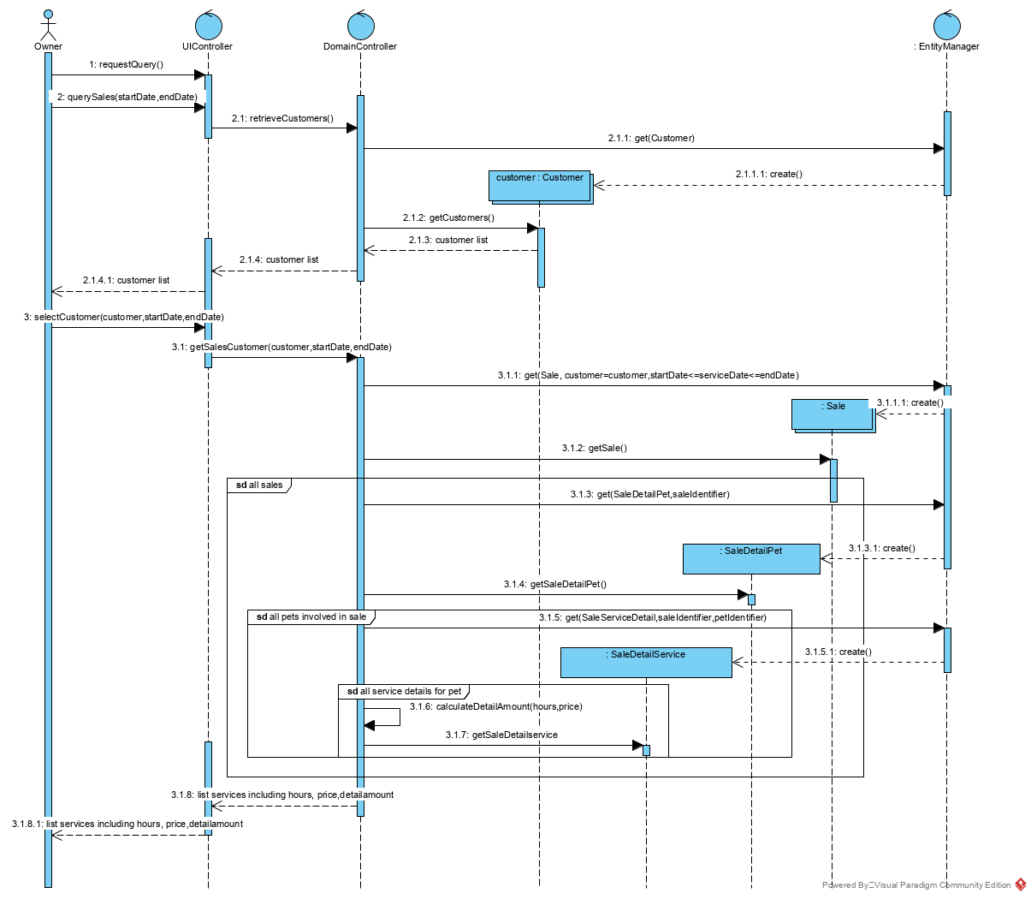

Lab Marks:

|  |  |
| --- | --- |
| Submit UML model on time | 1 |
| Discussion participation | 2 |
| Total | 3 |